|  |  |  |  |  |  |
| --- | --- | --- | --- | --- | --- |
| Date | 23-Nov-22 | | | Tester Name | Mohammad Yusuf |
| Environment | Penfax - Test | | | Login used |  |
| Operating System | Windows | Version: | Update: | | |
| Software Used | Select Software | Version: | Update: | | |
| Select Software | Version: | Update: | | |
| Release version |  | | | | |
| Title |  | | | | |
| Test Type | Regression | | | | |
| Test Scenario |  | | | | |
|  |  | | | | |
| Expected Results |  | | | | |
| Pass/Fail | Select | | | JIRA# | N/A |

Describe your steps with screenshots:

Pre-condition: Member is already on Leave.

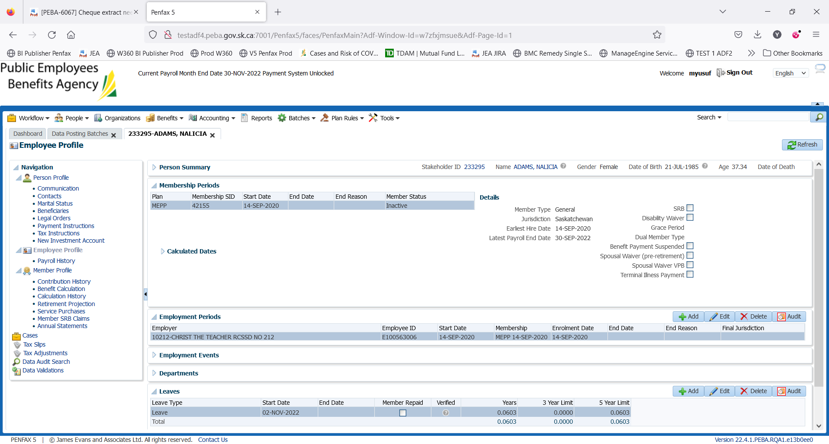

Select the Leave. Click on Edit button

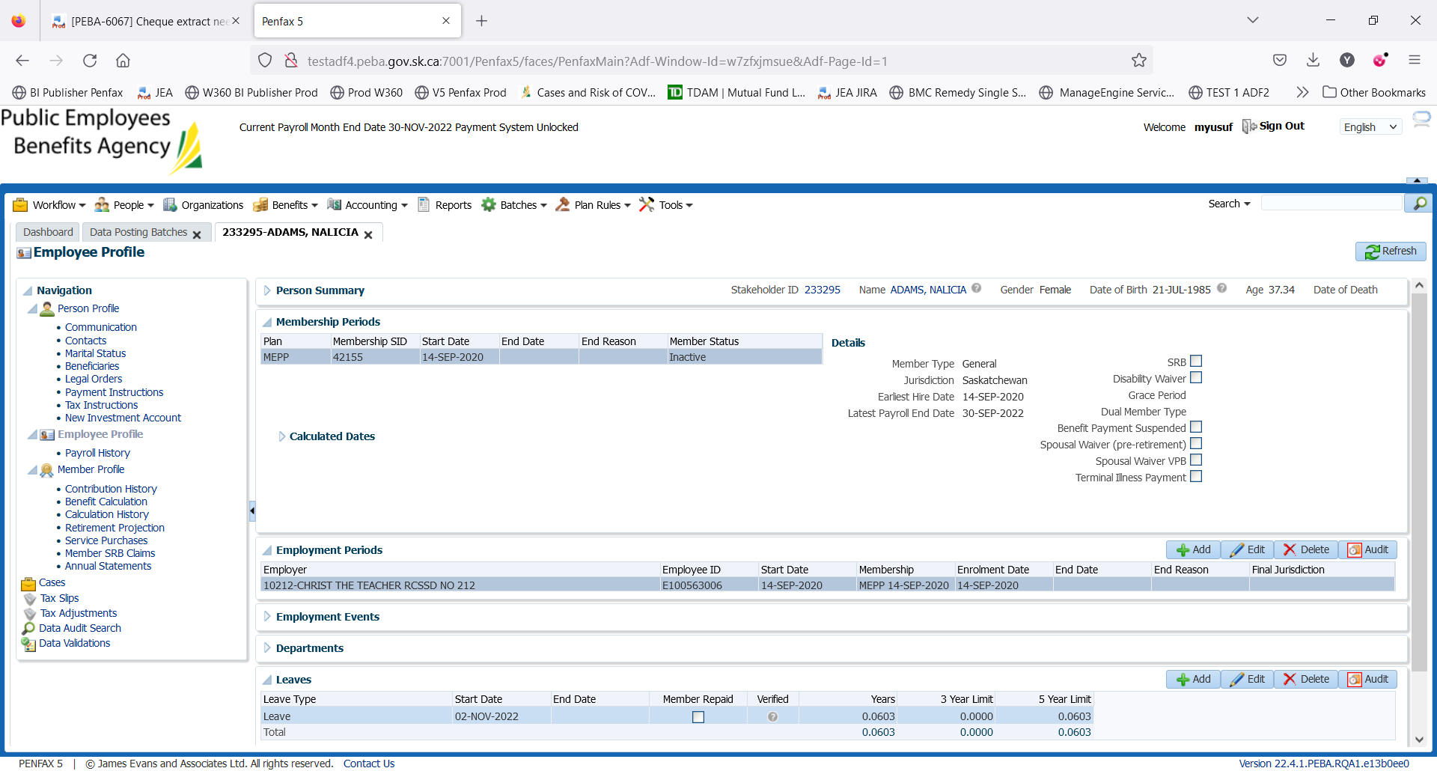

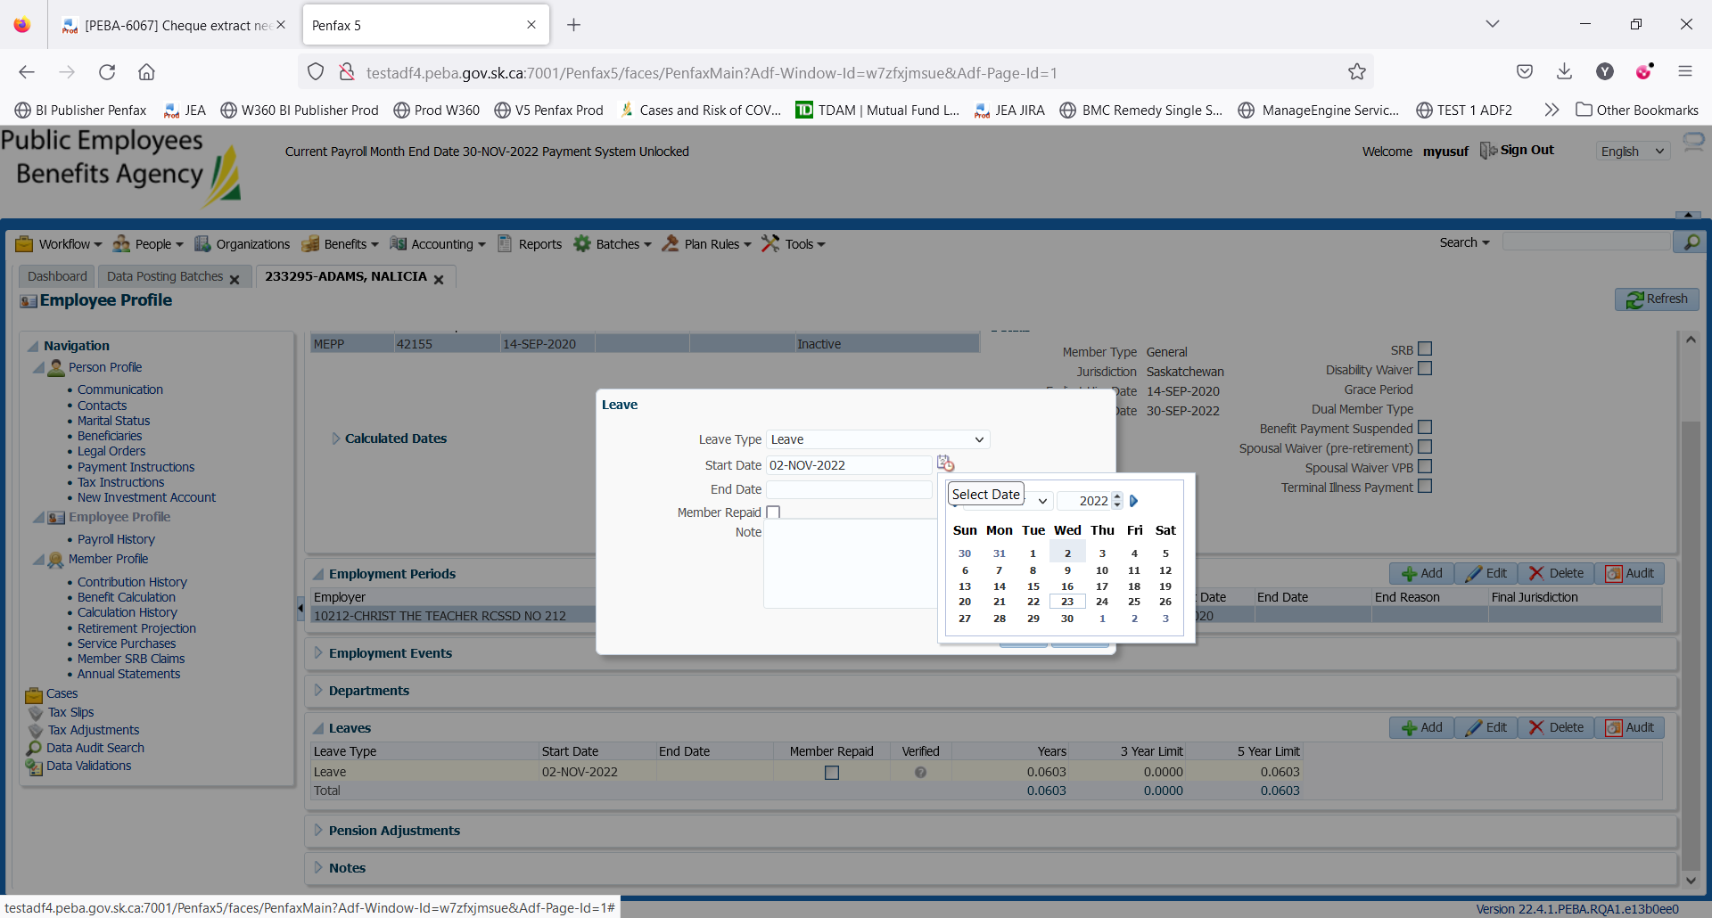

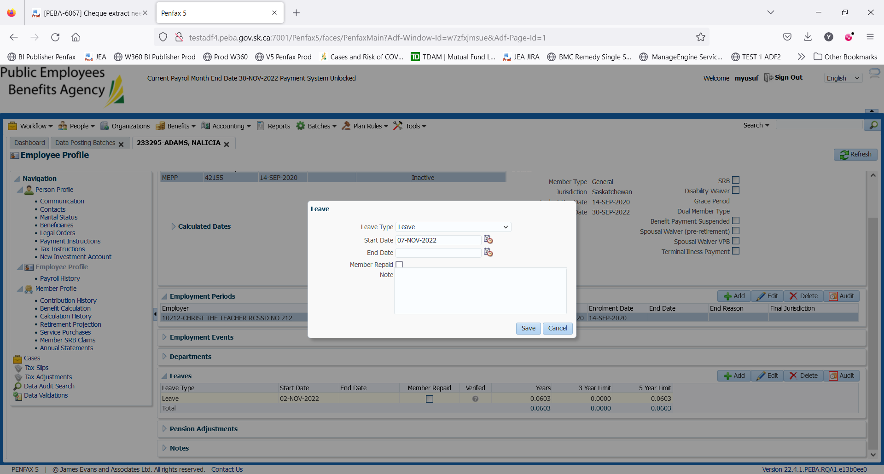

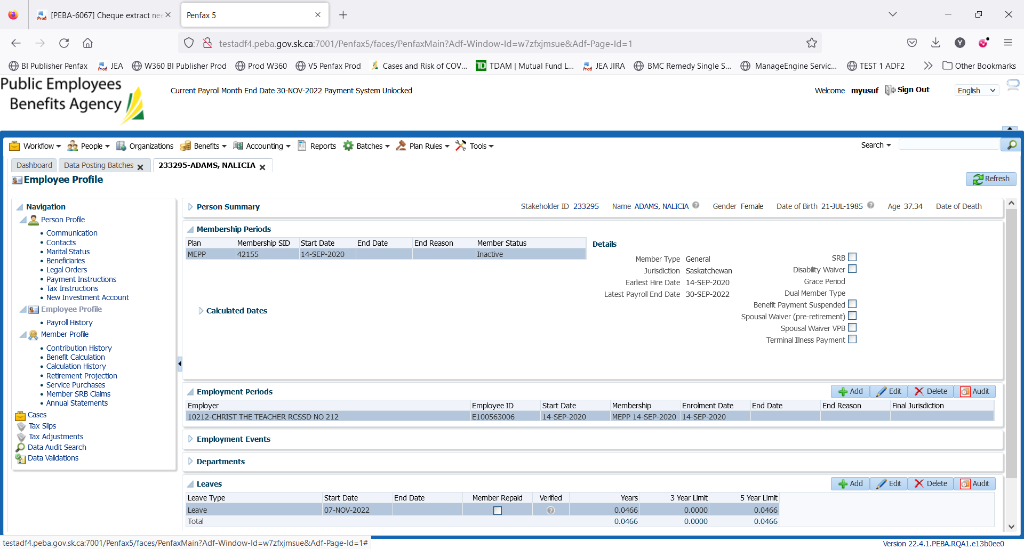

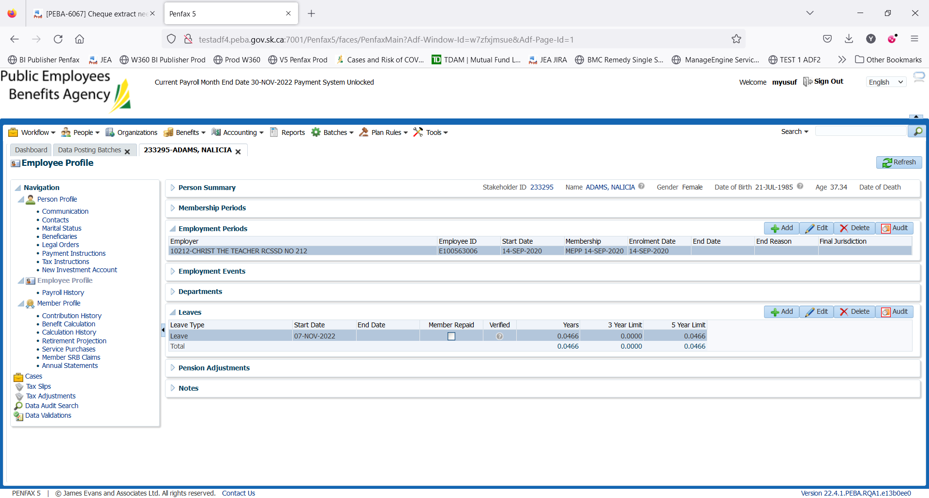

Click on the Calendar icon beside Start Date.

Select the new date as per the updated requirement

Save it. Change is updated in the system.

Please note: This Change can be done using DCT